SOFTWARE ENGINEERING PROJECT
ON
FAST FOOD BILLING SYSTEM


National Institute of Technology, Kurukshetra

Submitted by: Submitted to:
Vinay Kharb -123103092 Dr. M.K.Murmu
Mayank -123103093 Computer Engg. Avin Chaudhary-123103099 Department IT-B (06) (NITKurukshetra)

Problem Definition
Fast food is an ever-growing industry with huge opportunities of growth and automation. It requires speed and accuracy in order processing, but manual billing often leads to delays and errors, causing customer dissatisfaction and revenue loss. An automated system is essential to streamline operations, minimize human error, and ensure a faster, more efficient service tailored to the fast-paced nature of the fast food industry.

Objective
- Automate Billing Process: Develop a comprehensive and reliable solution to automate billing in fast food restaurants.
- Improve Order Accuracy: Enhance precision in order handling and billing.
- Seamless Integration: Integrate smoothly with inventory management and sales reporting systems.
- Scalability: Ensure the system is scalable to accommodate various sizes of fast food establishments.
- User-Friendly: Design the system to be easy to use for staff at all levels.
- Detailed Analytics and Reports: Provide in-depth analytics and reporting to aid decision-making and operational efficiency.
Abstract
The fast food billing system is a digital solution designed to automate and streamline the billing process in fast food establishments. This system includes features such as order entry, real-time billing, inventory management, and sales reporting. It aims to enhance operational efficiency, minimise errors, and provide a better customer experience. By integrating with existing point-of-sale (POS) systems and offering a user-friendly interface, the fast food billing system ensures quick and accurate transactions, ultimately leading to increased customer satisfaction and business profitability. The inclusion of data analytics helps businesses identify trends and optimize their operations. Additionally, the system supports scalability, making it adaptable to various sizes of fast food establishments, from single outlets to large franchises.

Target User
- Staff and Management: Cashiers, waitstaff, kitchen staff, and managers in fast food restaurants.
- Customers: Benefit from faster and more accurate service.
- Franchise Owners and Corporate Offices: Monitor performance, analyze sales data, and manage inventory across multiple locations.
- Marketing Teams: Utilize customer data for targeted promotions and loyalty programs.
Features
- User-friendly Interface: An intuitive and easy-to-navigate interface for quick and efficient operation.
- Order Management: Real-time order entry and processing to ensure accuracy and speed.
- Billing: Automated billing calculations along with discount offers and easy to read format.
- Inventory Management: Integration with inventory systems to track stock levels, manage supplies, and reduce waste.
- Sales Reporting: Detailed sales reports and analytics to help managers monitor performance and make data-driven decisions.
- Customer Database: Storage of customer information for loyalty programs, repeat orders, and personalised service.
- Multi-location Support: Capability to manage and synchronise data across multiple restaurant locations.
- Customisation: Flexible system settings to tailor features according to specific business needs.
- Promotions and Discounts: Capabilities to create and manage various promotions, discounts, and special offers, including automatic application of discounts during billing.

Benefits
- Increased Efficiency: Streamlined order processing and billing reduce transaction times and improve service speed.
- Enhanced Accuracy: Automated calculations and real-time updates minimise human errors in orders and billing.
- Improved Customer Satisfaction: Faster and more accurate service leads to a better customer experience and increased loyalty.
- Better Inventory Management: Real-time tracking of inventory levels helps prevent stockout and reduce waste.
- Data-driven Insights: Detailed reports and analytics provide valuable insights for decision-making and strategic planning.
- Scalability: The system can grow with the business, accommodating increasing transaction volumes and multiple locations.
- Cost Savings: Automation reduces the need for manual labor and minimises errors, leading to cost savings for the business.
- Operational Transparency: Enhanced visibility into sales and inventory enables better oversight and control.
- Employee Productivity: Simplified processes allow staff to focus on customer service rather than administrative tasks.
- Future-readiness: The system’s adaptability ensures it remains relevant as the business evolves and market dynamics change.

Data Flow Diagram (level 0)

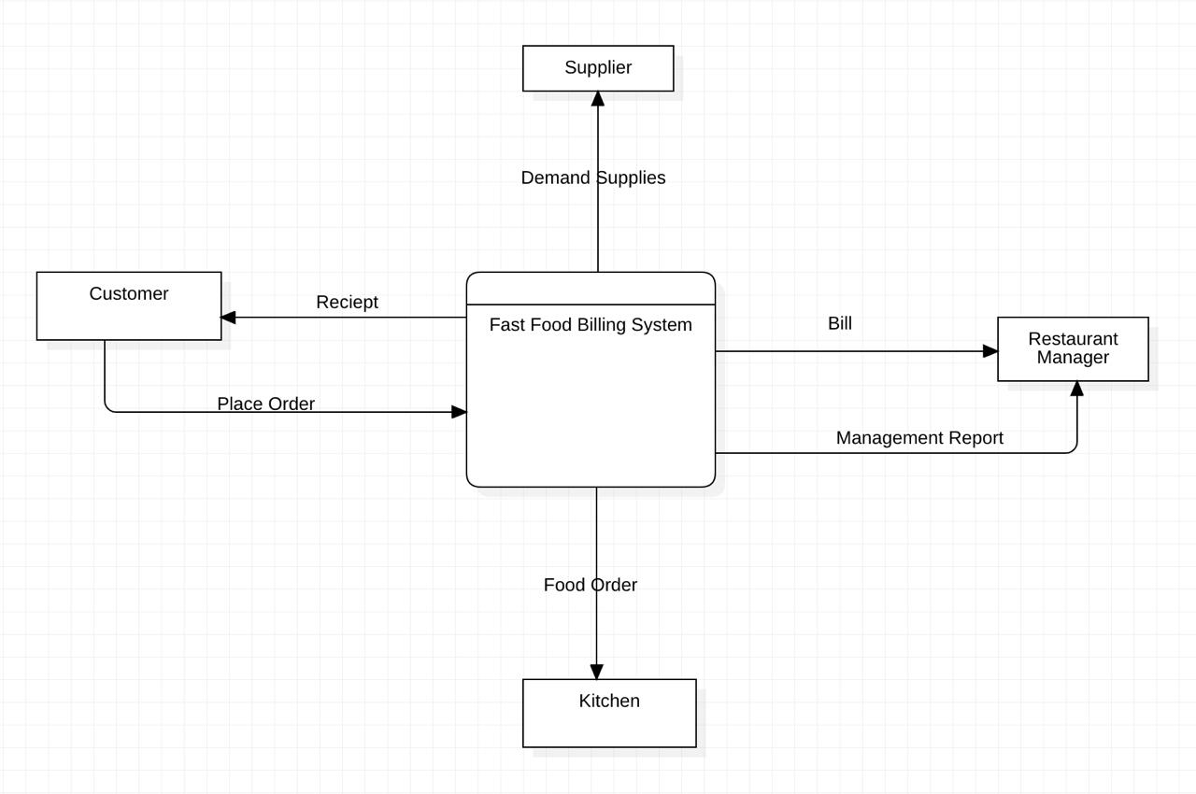

Data Flow Diagram (level 1)
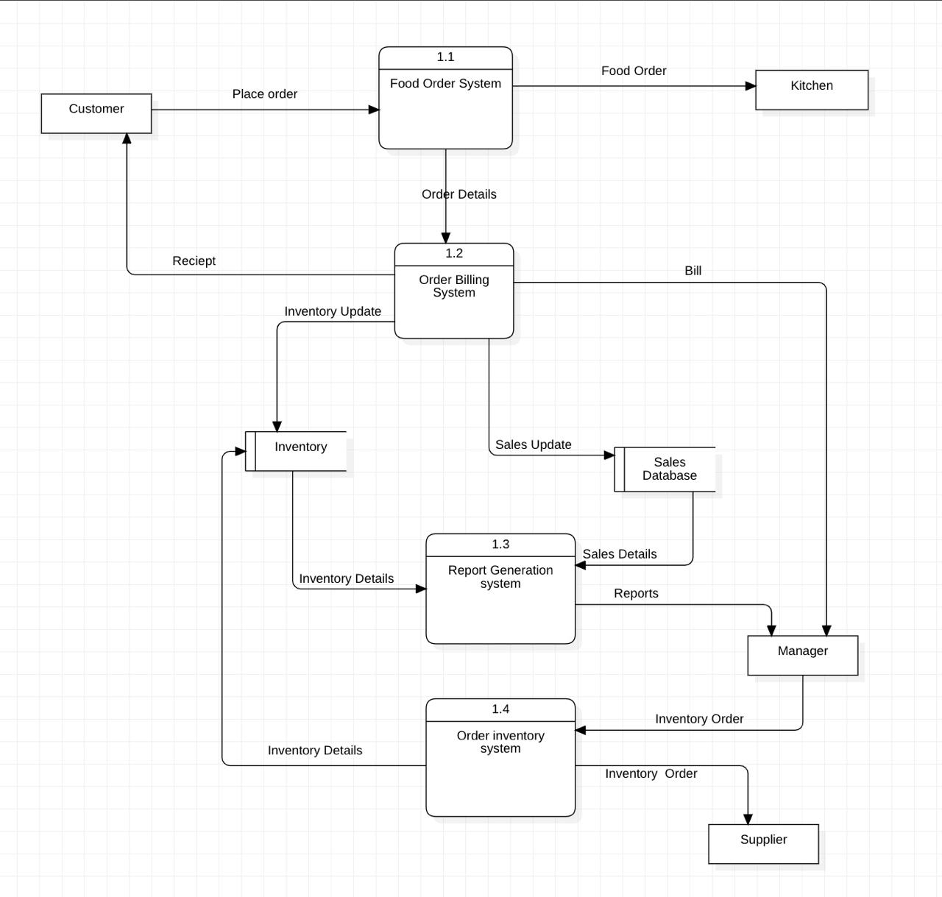
Description of Data Flow Diagrams

Level 0 diagram :

1. Customer to Fast Food Billing System:
The customer places an order which is sent to the Fast Food Billing System.
The Fast Food Billing System processes the order, generates a receipt, and sends it back to the customer.

2. Fast Food Billing System to Kitchen:
Once the order is placed, the system sends the food order details to the kitchen for preparation.

3. Fast Food Billing System to Restaurant Manager:
The system sends a management report and billing details to the Restaurant Manager for monitoring and administrative purposes.

4. Fast Food Billing System to Supplier:
Based on demand, the system sends supply requirements to the supplier to maintain stock levels.

Level 1 diagram :

1. Customer to Food Order System (1.1):
The customer places an order which is processed by the Food Order System (1.1).
The system then generates an order receipt and provides it to the customer.

2. Food Order System (1.1) to Kitchen:
The Food Order System sends the finalized order details to the kitchen for food preparation.

3. Food Order System (1.1) to Order Billing System (1.2):
The system passes the order details to the Order Billing System, which processes billing information and updates inventory.

4. Order Billing System (1.2) to Inventory:
The Order Billing System sends an update to the Inventory system to adjust stock levels based on the order.

5. Order Billing System (1.2) to Sales Database:
The billing system sends sales updates to the Sales Database, tracking all sales transactions.

6. Inventory to Report Generation System (1.3):
The Inventory system shares inventory details with the Report Generation System, which generates reports on stock levels and sales.

7. Report Generation System (1.3) to Manager:
The Report Generation System sends reports to the Manager for review and decision-making.

8. Inventory to Order Inventory System (1.4):
The Inventory system communicates inventory details to the Order Inventory System.

9. Order Inventory System (1.4) to Supplier:
The Order Inventory System generates an inventory order and sends it to the Supplier to replenish stock.

10. Order Inventory System (1.4) to Inventory:
The Inventory is updated with new supplies received from the Supplier.

